**Book Review**

**Book: - 1857: The Real Story of the Great Uprising- by Vishnubhatta Godse**

**My Review**

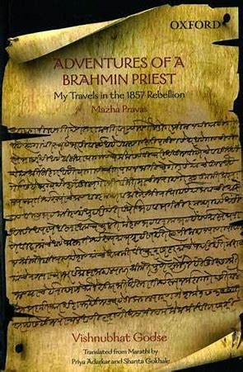

I read the book **1857: The Real Story of the Great Uprising- by Vishnubhatta Godse**. The original title of this book was **Mazha Pravas** which means ‘**My Journey**’.

This book is full of experiences and details in-depth about the Revolt Of 1857. In this book, he talks from a first-person perspective and describes the war in such detail that it makes you feel that you were present during the war. The book contains several historical narratives and pieces which are amusing and entertaining as well as informative

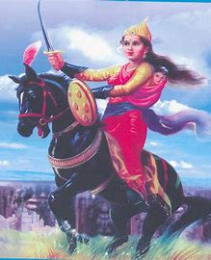The book has several pieces of description and amusing stories such as

The **description of Jhansi** and **details of Rani Laxmi Bai’s unusual life**. Her suicidal thoughts at imminent defeat, hosting a **haldi-kumkum ceremony** before **bravely leading an army of Arabs into battle** and then later, found weeping outside Kalpi on getting her period, show her as both a **vulnerable woman** and a **valiant leader**.

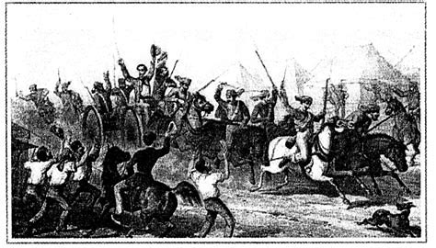The **status of widows**, the vast sums of money earned by the wealthy **brahmins**. Equally interesting is the story of the Gujarati moneylender who demanded that his money be returned with interest after the **British looted Jhansi** (and got it back) or the fact that “Madrasi” soldiers accompanying British soldiers were given **shoot-at-sight orders** if the latter were found “polluting” an Indian woman.

Vishnubhatta concludes by the line “**Thinking about our travels, I have realised that earning money is a difficult thing**”.

My favourite part in this whole book was the account on Rani Lakshmi Bai. The account explained her part in the revolt as well as her good deeds, habits and unusual lifestyle

**Quotes By Vishnubhatta Godse in his book**

“I thought to myself that it is indeed very difficult to earn money. And once you have earned it, you find it is even harder to retain it. Simply wishing for riches does not automatically generate money.” ― Vishnu Bhatt, Godse Versaikar, 1857: The Real Story Of The Great Uprising

“A beautiful area, with a large river flowing net to a temple to the Sun god situated towards the west. A section of the river near the temple is known as Suryavarta. It is believed... bathing it can cure all kinds of skin infection and ailments including eight kinds of leprosy...The lepers, after a dip in the river waters.... and pray every day until they are completely cured [Suryakeshetra in Bundelkhand]”

 ― Vishnu Bhatt, Godse Versaikar, 1857: The Real Story Of The Great Uprising

**Similar Books**

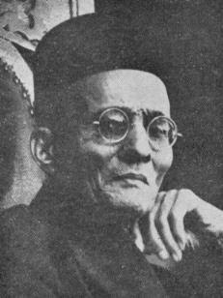

First war of Independence by V. D. Savarkar

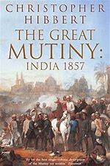

The Great Mutiny: India 1857 by Christopher Hibbert

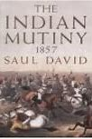

The Indian Mutiny: 1857 by Saul David

**Rating**

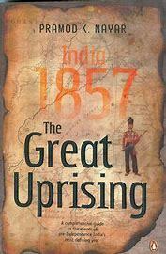

I would give the book a rating of **5/5**. This book gives you an **in-depth perspective** of the revolt. It's a **perspective of a bystander** and is so in detail. This book makes you feel that you are **present during the revolt**. I loved this book because it was so **in-detail** and made me feel as if I was present in the battle. It is an **unbiased** and **dispassionate first-person** account of events during the **first Indian freedom struggle**. It is a **one of a kind narration** by an **Indian** (most other accounts of the 1857 mutiny being by Britishers) from the **streets**, **palaces** and **homes of fellow countrymen**, including of the **Rani of Jhansi,** of the happenings during the war. It is an **honest** and **engaging** read, difficult to put down.